

Semester I 2024/2025
Subject : Database (SECD2523)
Section : 09 – Dr Haslina Hashim
Task : LAB 2-1 - Relational Model 1 (Keys)

Instruction:
Students are required to discuss the questions below.

QUESTION 01
Consider the following relations for a database that keeps track of student enrolment in courses and the book adopted for each course.
Identify the superkey, candidate key, primary key and foreign key (if any) for relations below:

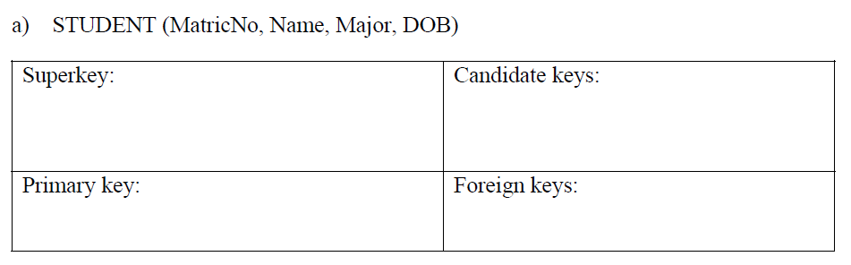
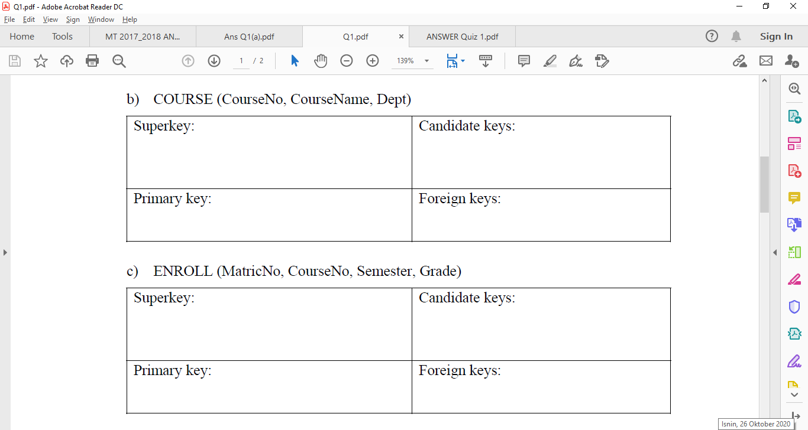
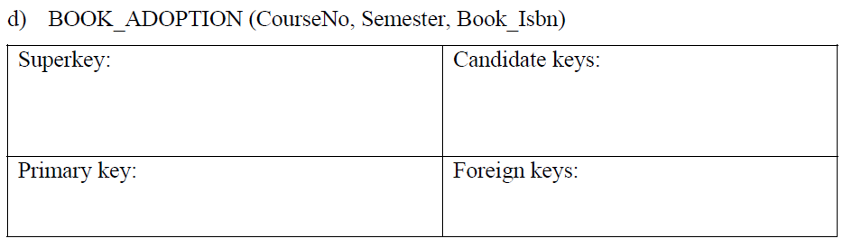

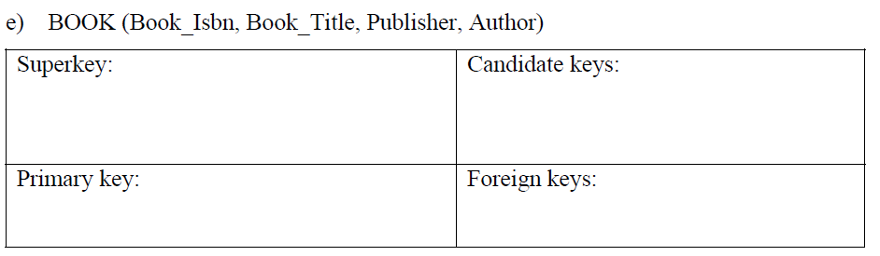
QUESTION 02
Identify superkey, candidate key, primary key and foreign key (if any) for relations below:

a) HOTEL (hotelNo, hotelName, city)
Superkey: | Candidate keys:
Primary key: | Foreign keys:

b) ROOM (roomNo, hotelNo, type, price)
Superkey: | Candidate keys:
Primary key: | Foreign keys:

c) BOOKING (hotelNo, guestNo, dateFrom, dateTo, roomNo)
Superkey: | Candidate keys:
Primary key: | Foreign keys:

d) GUEST(guestNo, guestName, guestAddress)
Superkey: | Candidate keys:
Primary key: | Foreign keys:

e) Explain how the entity and referential integrity rules apply to these relations.

QUESTION 03

The following tables from part of a database held in a relational DBMS

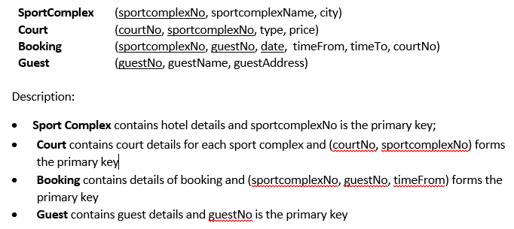
a) | For each of relation schema, identify foreign key (if exist).
b) | Explain how the entity and referential integrity rules apply to Booking and Court relations.

QUESTION 04
Refer to the tables below:

- For each table, identify the primary key and the foreign key(s). If a table does not have a foreign key, write None in the space provided. Provide your answers in the following format.
TABLE | CANDIDATE KEY(S) | PRIMARY KEY | FOREIGN KEY(S)
EMPLOYEE
STORE
REGION

- Do the tables exhibit entity integrity? Answer yes or no, and then explain your answer. Provide your answers in the following format.
TABLE | ENTITY INTEGRITY | EXPLANATION
EMPLOYEE
STORE
REGION

QUESTION 05
Consider a set of relations of student database as illustrate in the tables below:

STUDENT_Table
STUDENT_ID | STUDENT_NAME | ADVISOR_ID
1035 | Syafiq | 49
3397 | Jenny | 49
4070 | Sharul | 23

ADVISOR_Table
ADVISOR_ID | IC_NO | ADVISOR_NAME
23 | 670505084444 | Dr. Azizah
49 | 690909043333 | Dr. Ali

COURSE_Table
COURSE_ID | COURSE_NAME | COURSE_CREDIT
SCU 4044 | Project II | 4
SCK 2443 | Systems Development | 3
SCK 2423 | Database Systems | 3
SCK 0123 | Intro IT | 3

GRADE_Table
STUDENT_ID | COURSE_ID | GRADE
1035 | SCU 4044 | A
1035 | SCK 2423 | A
3397 | SCK 0123 | A
3397 | SCK 2443 | B
4070 | SCK 2443 | A

- For EACH relation above, identify the Primary Key and the Foreign Key (if any).

- There are TWO principal rules that apply to all instances of the above relations – entity integrity and referential integrity. By using the STUDENT_Table and ADVISOR_Table as cases, explain how both constraints pertain within these two relations.

